B-Tree Index Demo - 1

Login as DBA.

Remove all the cached data from buffer, all the sql statements from shared pool and set the tracing on by executing the following 3 commands.

Alter system flush buffer_cache;
Alter system flush shared_pool;
SET AUTOTRACE ON

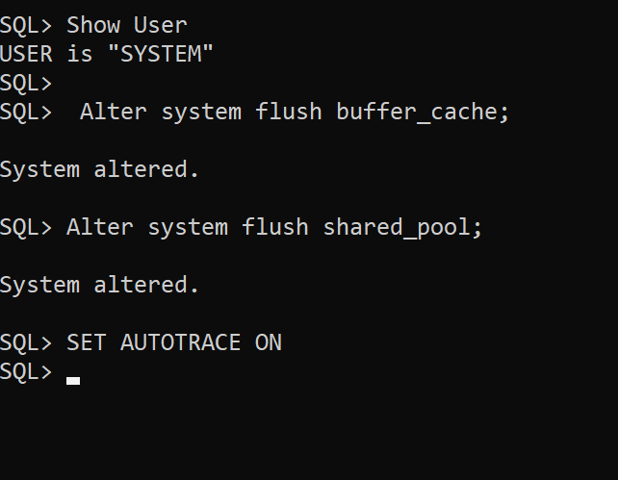

Let’s create a copy of Sales table as Sales2 in the Scott’s user account.

Create Table Scott.Sales2
As
Select * from Scott.Sales;

Confirm the number of rows.

select count(*) from Scott.Sales2;

The Sales2 table of user Scott has 30,000 rows. Its first column is OrderID which has all unique values. The OrderId values are from 1 to 30,000!!!!

Let’s execute a select statement on Scott user’s Sales2 table by filtering one particular record of a OrderId = 4834 when there is no B-Tree index created.

Alter system flush buffer_cache;
Alter system flush shared_pool;
SET AUTOTRACE ON
Cle Scr

select * from Scott.Sales2
where OrderID = 4834;

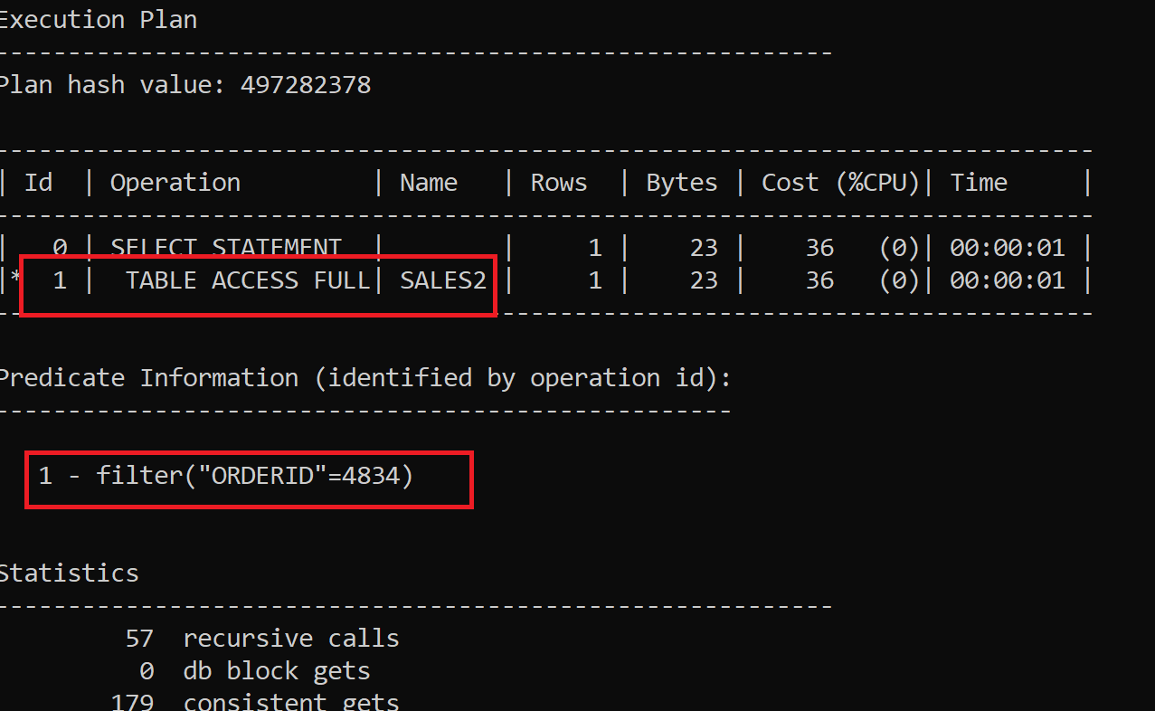

Notice that a full table scan has happened, which will slow down the query execution.

Again, remove all the cached data from buffer, all the sql statements from shared pool and set the tracing on by executing the following 3 commands.

Alter system flush buffer_cache;
Alter system flush shared_pool;
SET AUTOTRACE ON
Cle Scr

Now let’s create a B-Tree index on the column color of Scott’s sales table.

Create Index Scott_Sales2_OrderID
on Scott.Sales2(OrderID);

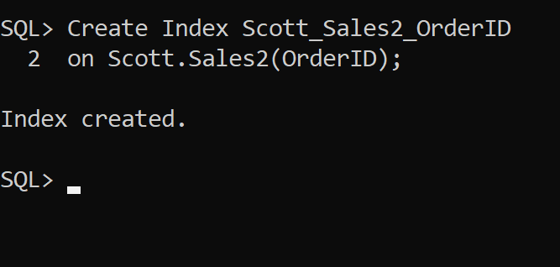

Note B-Tree is the default type of index, we do not have to mention any keyword. Actually, there is no keyword for B-Tree index type. Just create index indexname means Oracle is going to create a B-Tree index only!!

After indexing the column again reset memory and environment

Alter system flush buffer_cache;
Alter system flush shared_pool;
SET AUTOTRACE ON
Cle Scr

B-Tree used for searching records with equality operator

Now execute the same select statement:

select * from Scott.Sales2
where OrderID = 4834;

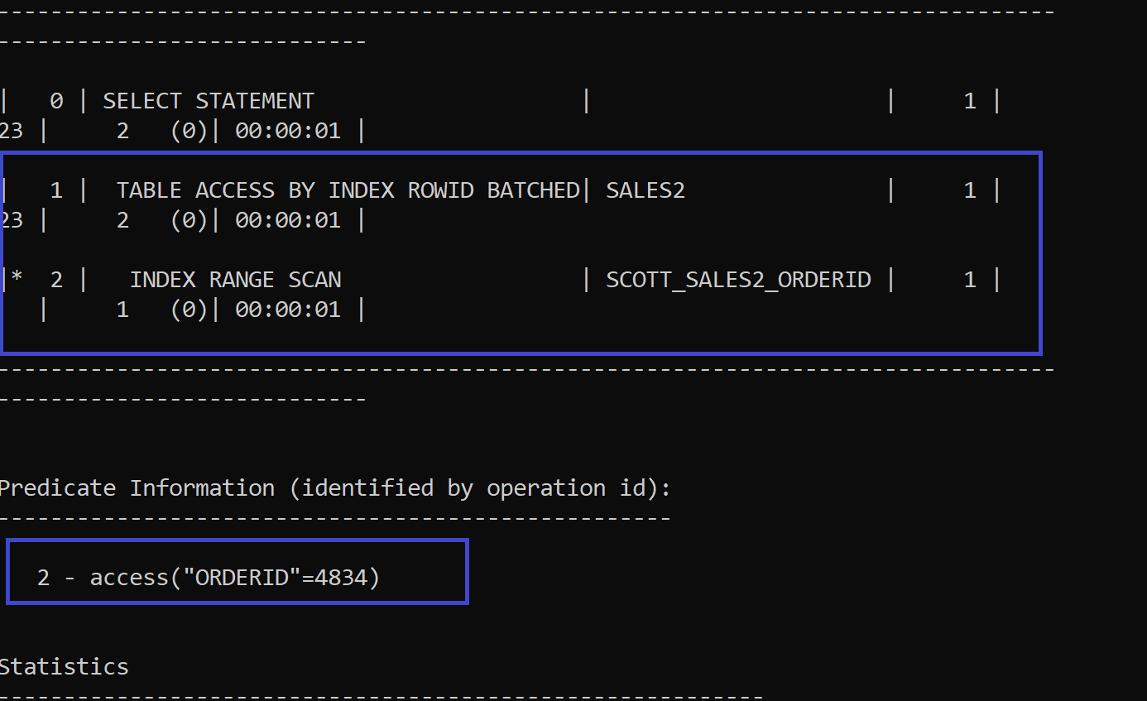

Notice Now the Full Table Scan has not happened!! Rather it has scanned through the B-Tree index values!!!

What is the meaning of INDEX RANGE SCAN in Oracle?
Answer INDEX RANGE SCAN is generally efficient for retrieving a subset of rows from a table when the queried column(s) have been indexed. It's particularly useful when the WHERE clause involves range predicates such as greater than (>), less than (<), between, etc.
It is relevant for Btree Index.

B-Tree used for searching range of records

If the rows span the DIFFERENT or Discontinous Leaf nodes then it will NOT go as per Index Search

Alter system flush buffer_cache;
Alter system flush shared_pool;
SET AUTOTRACE ON
Cle Scr

select * from Scott.Sales2
where OrderID between 11001 And 17078;

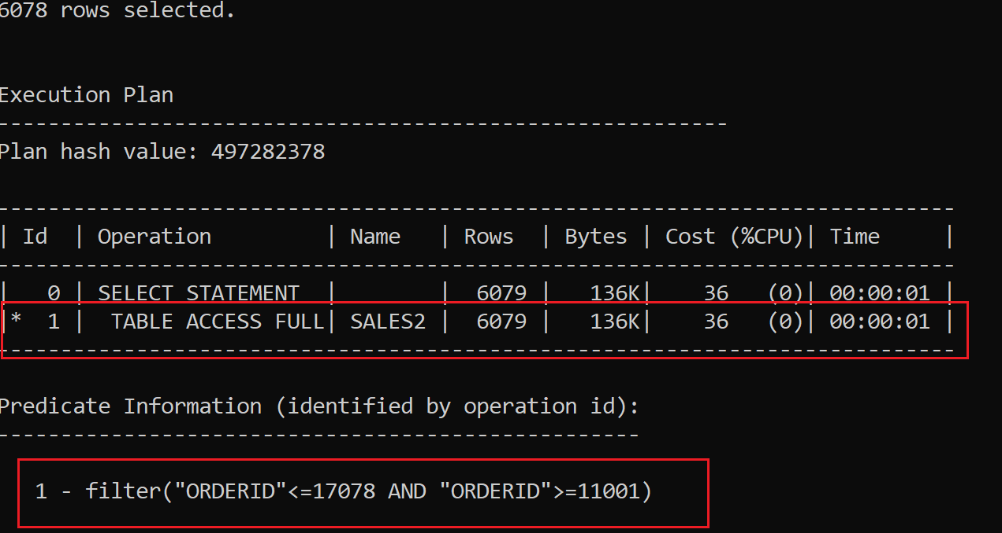

If the rows span the SAME or near by Leaf nodes then it will go as per Index Search

Alter system flush buffer_cache;
Alter system flush shared_pool;
SET AUTOTRACE ON
Cle Scr

select * from Scott.Sales2
where OrderID between 2 and 200;

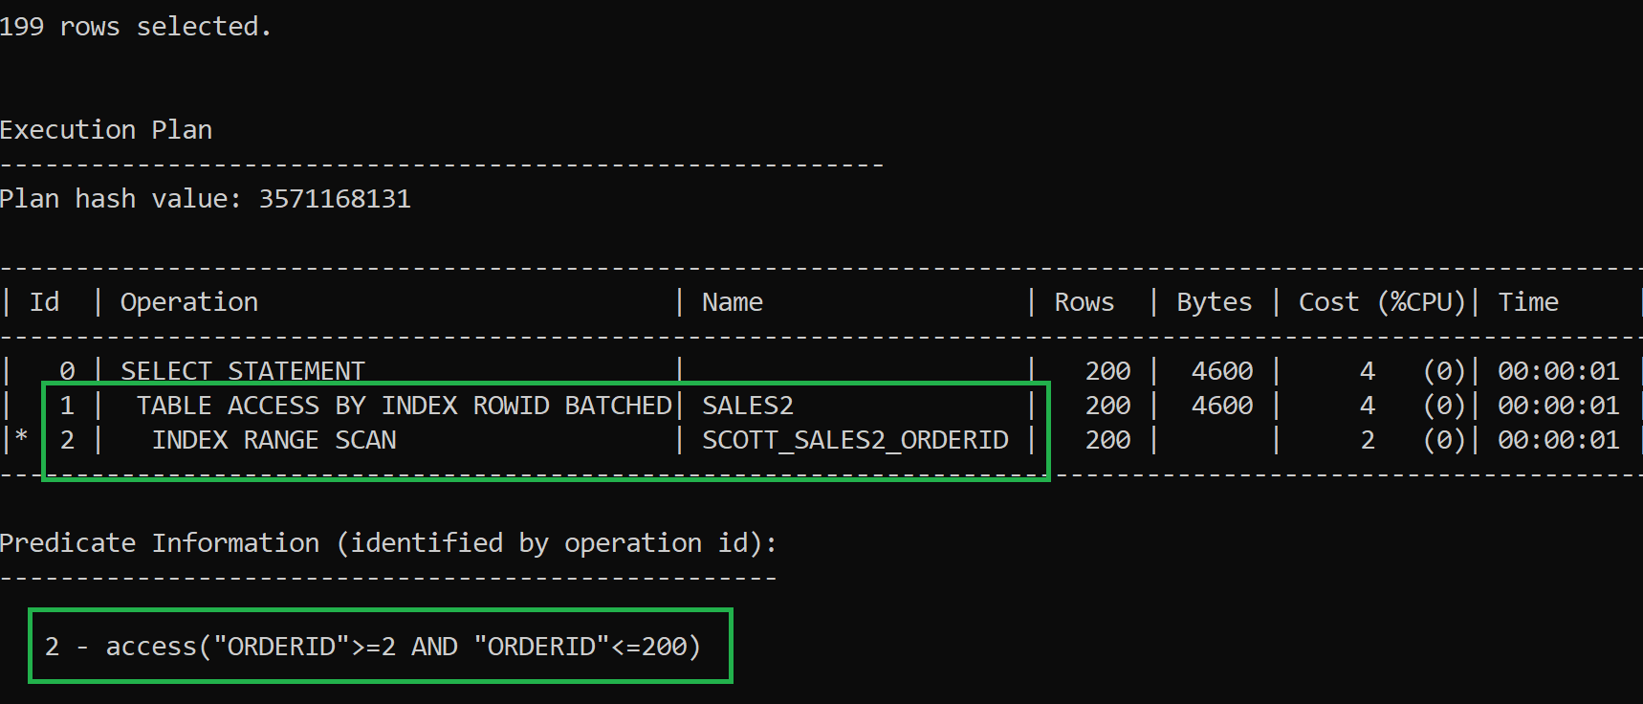

B-Tree used for searching its null values

For that let’s make some order id null.

Update Scott.Sales2
Set orderid = null
Where OrderId = 1567; -- While updating it uses index

Alter system flush buffer_cache;
Alter system flush shared_pool;
SET AUTOTRACE ON
Cle Scr

Now we will se that record.

select * from Scott.Sales2
where OrderID is Null;

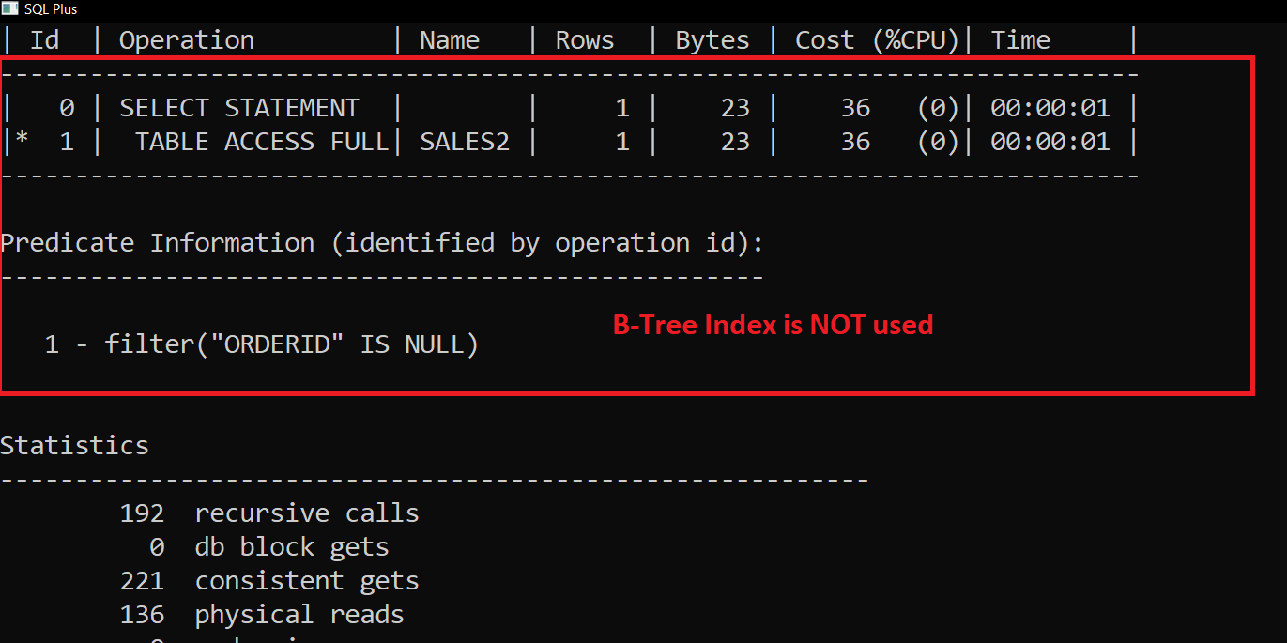

(Bitmap Index keeps track of null values as well!!)

B-Tree used for searching its not null values

What is the condition says order is not null??

Alter system flush buffer_cache;
Alter system flush shared_pool;
SET AUTOTRACE ON
Cle Scr

select * from Scott.Sales2
where OrderID is Not Null;

